Memorandum
City of Lawrence
Public Works

TO: | Mike Wildgen, Dave Corliss, Debbie Van Saun
FROM: | Chuck Soules
Date: | May 10, 2005
RE: | Agenda Item - Vacation of Right-of-Way – Turney and Hayden
Attached are two requests for vacation of right-of-way:

1. Austin and Ruth Turney have requested:
- The vacation of the 60 ft. right-of-way of Delaware Street from 15th Street south approximately 383 feet.
- Delaware Court.
- The east half of the right-of-way of Pennsylvania Street from 15th Street south approximately 600 ft.

These areas are identified on the attached map in yellow. All utilities and neighboring owners were notified. The city does have a water main in the right-of-way of Pennsylvania Street and, therefore, an easement will need to be retained.

Since the right-of-way of Pennsylvania Street was platted from the Turney’s property, staff is recommending that the vacated area be returned to their ownership.

2. Stanley and Linda Hayden have requested the vacation of the Delaware Street right-of-way adjacent to their property. This area is identified on the attached map in red. There are no utility conflicts and no comments have been received from neighboring properties. This is a dead-end street with no turnaround (430 ft. length).

Action Requested: Open public hearings and, pending discussion:
- Approve Order of Vacation for the Turney’s request, retaining a utility easement on Pennsylvania Street and returning the vacated right-of-way to the Turney tract.
- Approve Order of Vacation for the Hayden’s request (that portion of Delaware Street adjacent to their property).

Respectfully submitted,
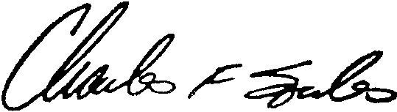
Charles F. Soules, P.E.
Director of Public Works

CFS/je

Attachments

